Briana Salatino | 1:11 PM (6 hours ago)
to bcc: me

Hi all,

I come bearing good news! You have been selected as the 31 artists for Kate Bryan's '31 Women' exhibition onsite at The Other Art Fair! We did a similar exhibition at the London fair last weekend which garnered tons of great press for the artists and the fair as a whole.

Below is a little bit about the 31 Women exhibition and what it represents:

Curated by Kate Bryan, Arts Broadcaster and Head of Collections for Soho House and Co. globally, 31 Women marks the 31st edition of The Other Art Fair and the 75th year anniversary of the iconic exhibition of the same name at Peggy Guggenheim’s gallery, Art of This Century.

31 women takes the form of a small exhibition within the main context of the fair, highlighting one work each by 31 female artists who are all participating in The Other Art Fair LA. This mini salon draws together sculpture, collage, neon, photography, figurative and abstract painting in the same inclusive spirit of Guggenheim’s original show.

The original 31 women took place in January 1943 at Guggenheim’s New York gallery. It was the first exhibition of its kind to highlight women artists who were largely absent from mainstream gallery and museum shows. Over 7 decades later permanent collections in museums across Europe and North America have on average only 3-5% artwork by female artists. At best you can hope to see women’s artwork around 30% of the time in a progressive gallery or institution, in most it is often far less. This exhibition is therefore part homage to Guggenheim, one of the greatest art patrons of the twentieth century, but it is also part protest against the continued male dominance of the art world today.

Congratulations on this amazing accomplishment! We'll be in touch soon to request artworks for the exhibition.

Best,
Briana

--
_________________________

Briana Salatino
Fair Assistant
The Other Art Fair - Los Angeles

e: briana@theotherartfair.com
w: theotherartfair.com

fb: facebook.com/theotherartfair
tw: @theotherartfair
insta: @theotherartfair

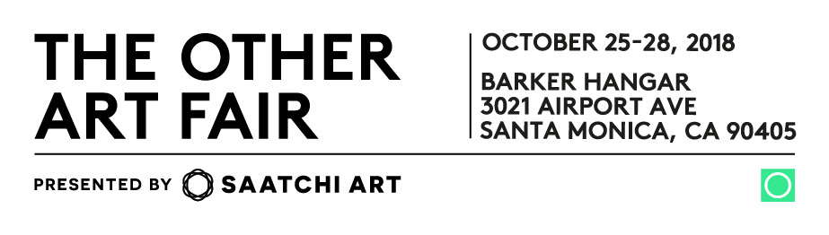
Please NOTE: This electronic message, including any attachments, may include privileged, confidential and/or inside information owned by Leaf Group. Any distribution or use of this communication by anyone other than the intended recipient(s) is strictly prohibited and may be unlawful. If you are not the intended recipient, please notify the sender by replying to this message and then delete it from your system. Thank you.

